Applications for the training of new Verifiers

European Charter for Sustainable Tourism in Protected Areas (ECSTPA)

The EUROPARC Federation is the network for Europe’s natural and cultural heritage. Created by our members, the Federation works, to improve the management of Protected Areas in Europe through international cooperation, exchange of ideas and experience, and by influencing policy.
The EUROPARC Federation has long recognised the need to take care of both the land and the people who live and work there, and often derive their livelihoods from those who come to appreciate these special places.

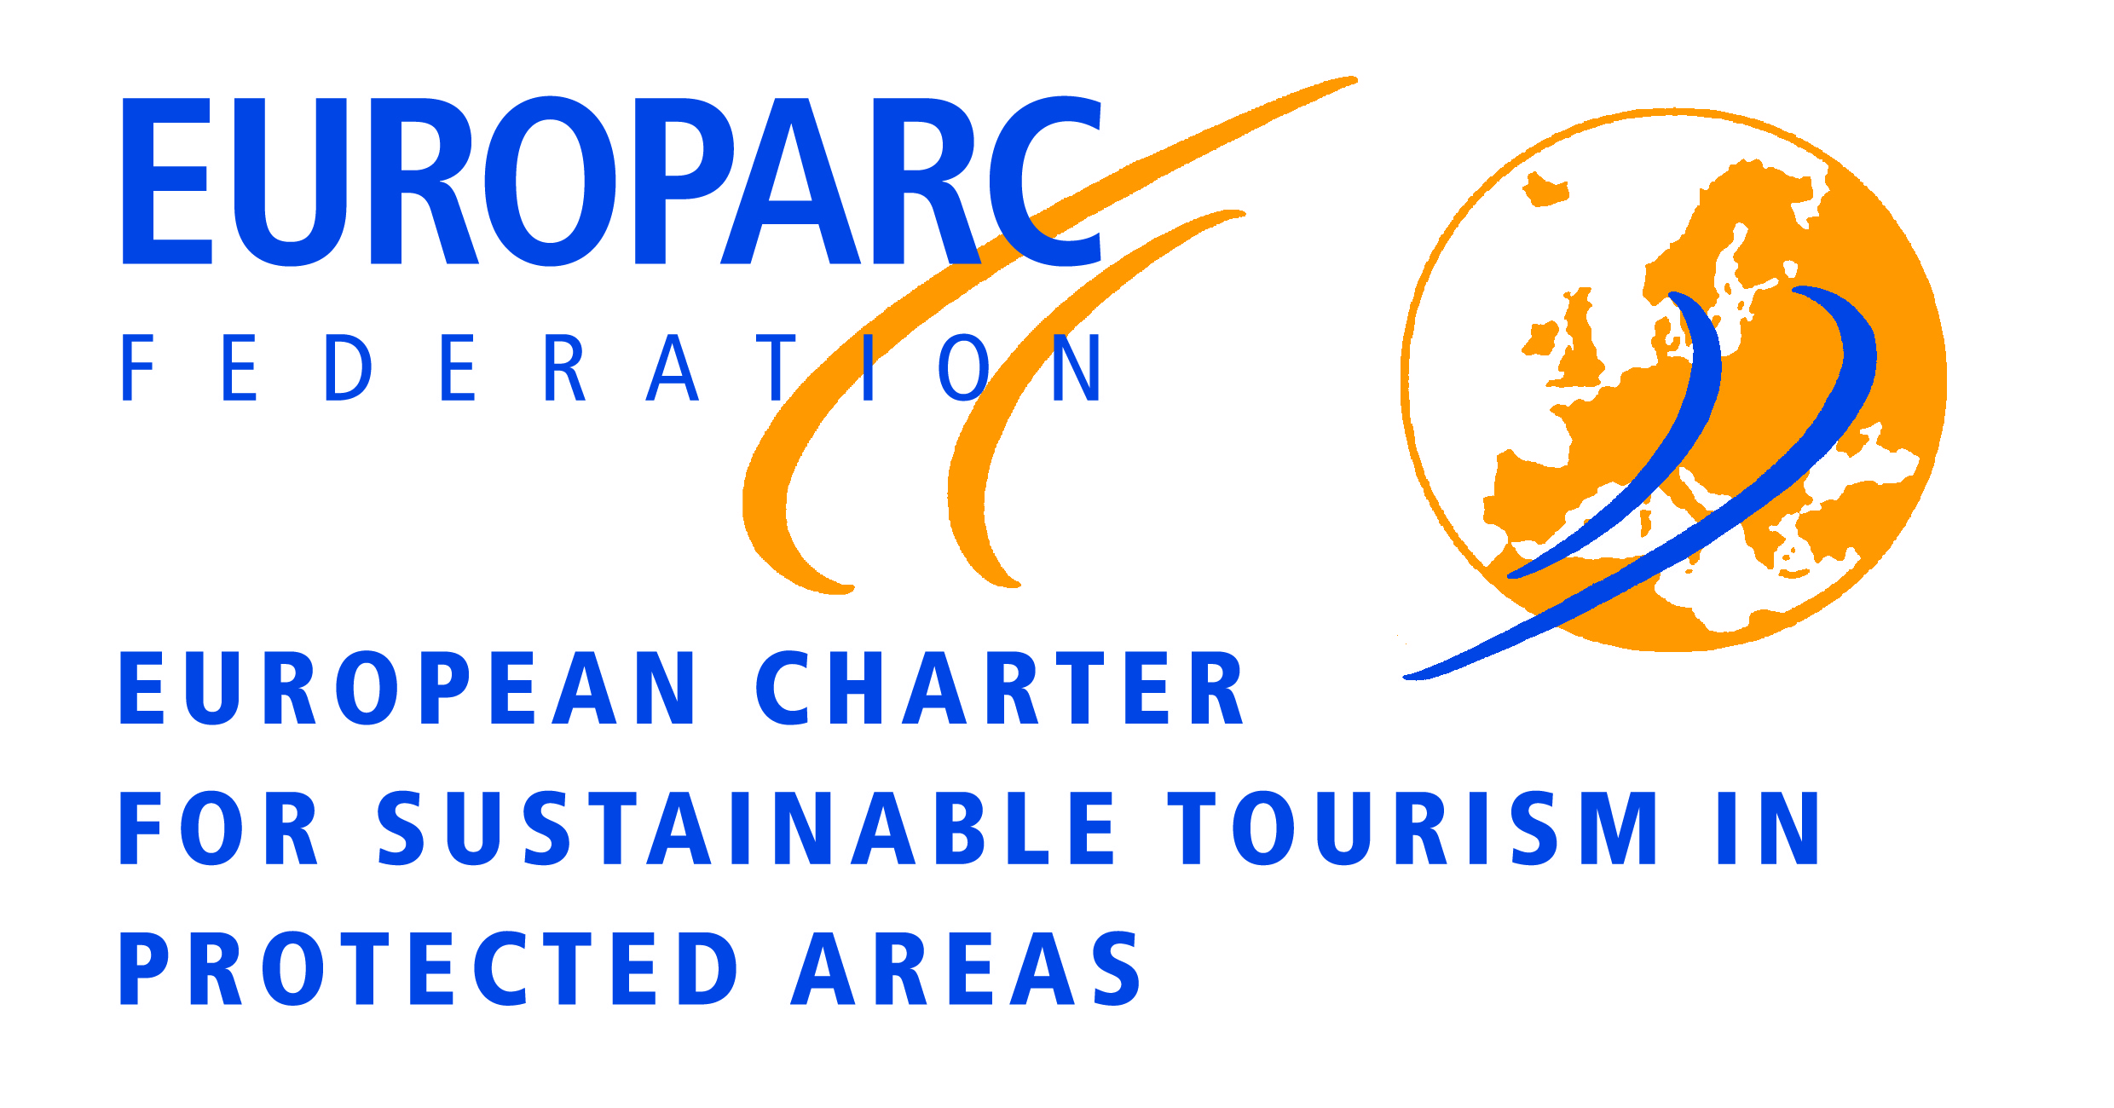
The European Charter for Sustainable Tourism in Protected Areas (ECSTPA) is a practical management tool that enables Protected Areas to develop tourism sustainably, bringing environmental, social and economic benefits to the region.

The ECSTPA has been implemented over the past decades in several European countries and a wide range of expertise and experience has been built up. Up to now, 144 protected areas have been certified as Charter areas and this number is likely to increase over the years. Central to the ECSTPA is its evaluation process, and with the use of the ECSTPA becoming so widespread it is very important that the evaluation process maintains its high standards and credibility.

Charter Verifiers
At the heart of the evaluation process are the verifiers – a European network of experts and experienced professionals. The last verifiers training was held in 2011, and in order to ensure that standards are maintained and improved it is proposed to train new verifiers, especially for those countries where the interest in the Charter is growing and to anticipate new developments in Charter parks across Europe.
As a member’s organisation we want not only to support the work of your park or organisation, but to offer opportunities not just to develop your skills and experience, but also to share that experience with others.

The opportunity to train as a verifier of the ECTSPA, will give you a chance to join a network of international professionals in the field of sustainable tourism and protected areas. The benefits of being a verifier include the opportunity to visit various European Protected Areas, by learning and assessing their various work produced, gain knowledge and understanding of the operational context of a protected area and how this has engaged with its stakeholders, the possibility to meet with various professionals and local experts, and assess the work done at the local level.

Become a Charter Verifier: What is needed
- In order to become a verifier you will need to show a proven expertise in the field of protected areas, sustainable tourism and participatory planning/community engagement.
- Verifiers will have to adhere to the code of conduct of the Federation and act as their ambassador and representative during their given assignments.
- Verifiers will have to ensure high quality and timely delivery of the verification reports in English.
- It is therefore required an excellent command of English (europass C2 writing) so to submit a clear, smoothly-flowing description or argument in a style appropriate to the context and with an effective logical structure which helps the Evaluation Committee to notice and remember significant points.
- It is also required a proven previous knowledge of the operative context of protected areas, experience in the field of sustainable tourism.
- Please note that availability on training dates is mandatory!

If you are interested and if you think you can fulfil the criteria, then apply to become a Verifier.

What to do
To apply to become a verifier please send your CV (in English) along with the completed form below by Friday, 1st July so that we can start the selection procedure. We will confirm if you have been selected in early August.
Training it will take place in Siggen in Northern Germany from 14th to 17th November 2016. It is mandatory to attend. We will send out a draft programme. Travel costs up to €350 will be reimbursed. Room and board are included.
The training will involve sessions looking at both programmes in relation to the EUROPARC strategy and sessions looking at how to verify a charter area. Communications skills and an in-depth look at the application forms and procedures is also included.

People who take part in the seminar will be expected to use their training exclusively for the Federation and to be available as verifiers for the Federation once or twice a year as a charter verifier.
We look forward to receiving a great feedback and for inquires to this regard please contact:
info@european-charter.org
Cordially yours,
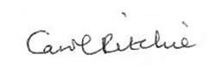
Carol Ritchie
Excecutive Director
EUROPARC Federation

Application form (to be sent to info@european-charter.org )

My contact information:
Mr / Mrs
Name:
Institution/organisation:
Address:
Tel.:
E-Mail:
Skype:
Nationality:

Skills and experiences:
Please list the languages you speak and to what degree of fluency (europass A1, A2, B1, B2, C1, C2):

Please briefly list your knowledge and experience on sustainable tourism in protected areas:

Please briefly list you knowledge and experience on participatory planning/ community engagement:

Please list your skills and experience that makes you a good candidate as a charter verifier:

Please include a motivation letter explaining why you want to become a charter verifier.

