Siggen Seminar 2018
Registration form page 1 of 2

Please fill in the registration form below and return it to EUROPARC Federation at: b.pais@europarc.org

I hereby register to participate in the seminar “Interpreting natural heritage, as part of our cultural identity in Europe’s Protected Areas”.

My Contact information:
Mr |  | Mrs
Name:
Institution/Organisation:
Address:
Country:
Telf.:
E-mail:
Skype (if applicable):

Travel details:
When do you expect to arrive?
When are you leaving?
Do you have any dietary requirements?
Any other information you might find relevant:

Continues on next page
Siggen Seminar 2018
Registration form page 2 of 2

Other information:
What is your position and role in your organisation?
What is the reason for attending this Seminar?
Will you be bringing a case study on this topic?

Please tell us a bit about it.

After attending the Seminar, how will you pass your knowledge onto other members of staff afterwards?

Contacts:
If any problems on your way to Siggen please use call the EUROPARC office +49 (0) 941 59935980 who will direct your call to the seminar organiser.
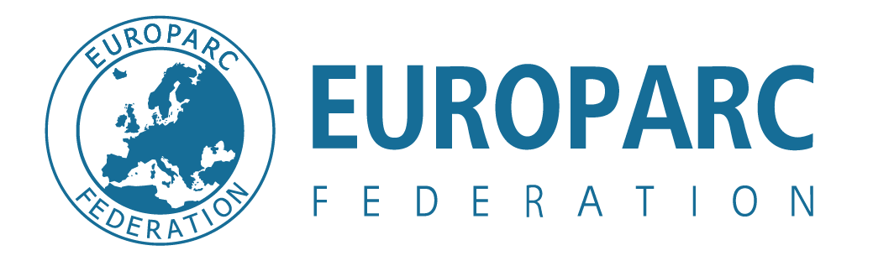
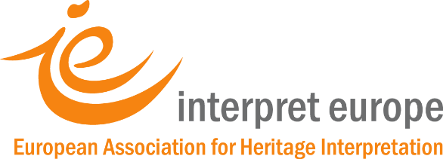
The Siggen Seminar 2018 is organised by:

A celebration of:
Supported by:

