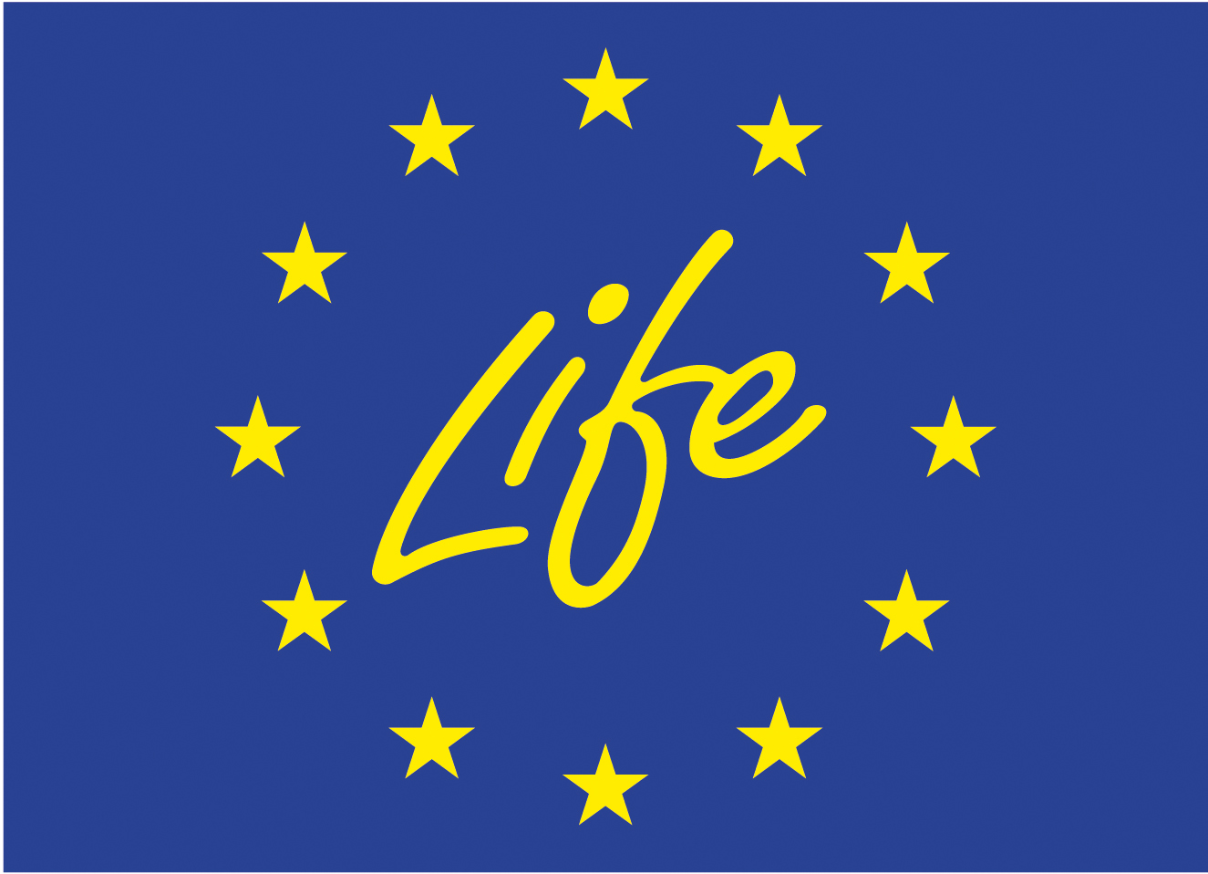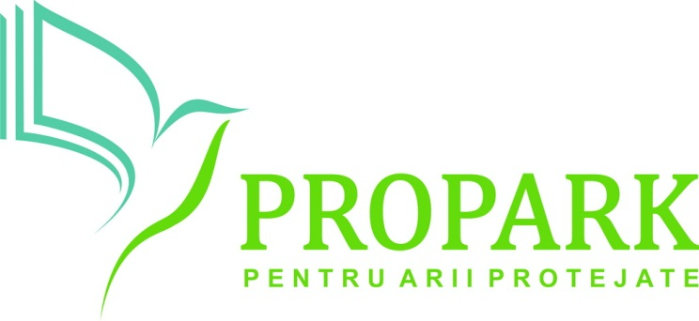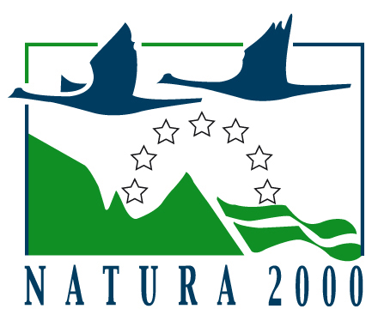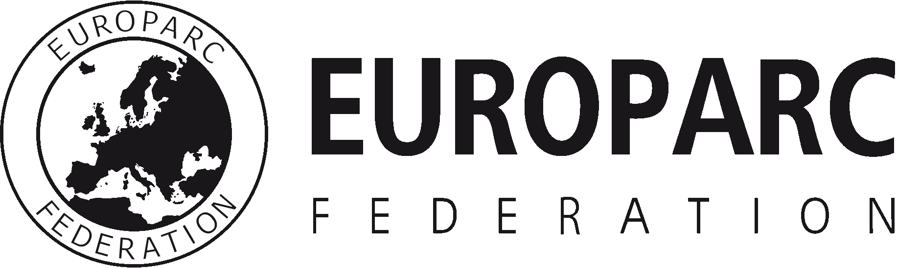

EUROPARC Federation

Best practices on communicating Natura 2000 sites

The aim of the project is to increase the management capacity and support for Natura 2000 sites in Romania by developing site managers communication skills and supporting the integration of biodiversity concerns in territorial planning processes in and around Natura 2000 site.

One component of the Efficient Managers for Efficient Natura 2000 Network project is to develop and disseminate best practice guidance and improve skills and capacity of site managers on communicating Natura 2000 by providing high quality communications training programme and producing a communication toolkit for Natura 2000 managers in Europe.

This toolkit will contain a list and presentations of the different case studies collected. The best case studies will also be rewarded during EUROPARC Federation 2015 Conference that will take place in Regensburg (DE) on the 26th and 27th of October.
The deadline for application is the 1st of September.

Template for submitting Case Studies

Information required | Guidance | Your text
Title of your project / initiative / event / action | The title should be short.
By-line | Please write one short sentence to describe the project
Location | Please tell us where the project / activity is (or was) taking place
Summary | Please write a paragraph to summarise the projects’ original aims, and what was produced (max 200 words)
Outcomes / Results | Please provide a list of bullet points showing the results of your work
More information about the project / initiative / event… | Please describe the project and provide some explanations:  Examples:  - Policy – please tell us about the situation before & after policy development  - Evidence – please tell us how the project was funded  - Delivery – please explain the target audience, and the type of communication tools used
Key messages / lessons learned | What have you learned from your project (so far)?  Please provide a list of bullet points showing key learning points, designed to help readers benefit from the case study author’s experience
Further Information | Please provide us with some supporting material for your example i.e. web sites, various photographs to help with design, and contact details for the coordinating organisation.  You can also attach leaflets, brochures etc

