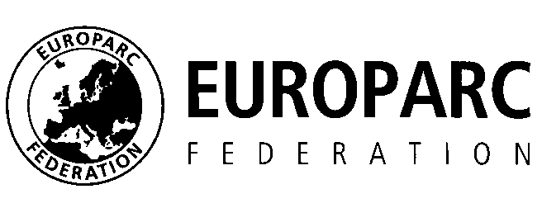

Nomination
Alfred Toepfer Medal 2018

Name of nominee:
Sex:
Date of Birth:
Academic title (if available): Nationality:

Organisation/Employer:

Achievements

Reasons why she/he should win this accolade:

Please send this form and any additional material to b.napolitano@europarc.org until June 29, 2018.

Name of nominator:
Organisation:
Country:
Contac details:
Thank you very much!

