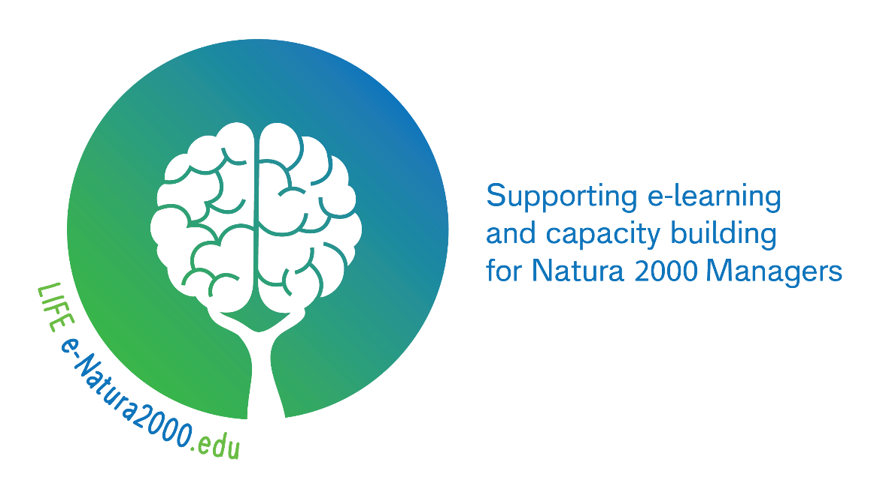

Short description
This innovative three-year project explores the potential of building new approaches and learning methods to improve knowledge and capacity amongst Natura 2000 Managers in both public and private land, across the EU. Taking a competence based approach, it will enable peers to connect and learn about what managers need to know and be able to do. The project will analyse training needs and make available new ways of accessing information about the multiple skills required for Natura 2000 management and policy implementation.

PROJECT IN A NUTSHELL
A LIFE Preparatory Project made possible with the support of the LIFE financial instrument of the European Community
- SHORT NAME: LIFE e-Natura2000.edu
- TOTAL BUDGET: €845k
- DATES: START 1.4.2018 / END 31.07.2021
- 7 PARTNERS FROM 7 COUNTRIES
- PARTICIPANTS FROM ACROSS THE EU
- 6 IMPLEMENTATION ACTIONS,
5 COMMUNICATION ACTIONS &
5 PROJECT MANAGEMENT ACTIONS
- 34 DELIVERABLE OUTPUTS

Project Partners
The project is led by The EUROPARC Federation with the direct involvement of six partners:

- ProPark Foundation for Protected Areas,
- Fundación interuniversitaria Fernando González Bernáldez para los espacios naturales (FUNGOBE)
- University of Padova, Dept Land, Environment, Agriculture and Forestry (TESAF)
- The European Landowners Organization
- Rangers Campus
- Kullaberg Nature Reserve
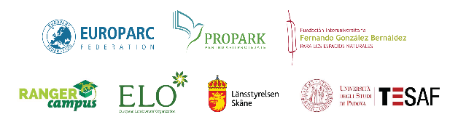

How the project will work
LIST OF ALL ACTIONS
- Implementation actions

Action n. | Name of the action (obligatory):
A1 | Identification and assessment of competencies for management of Natura 2000
A2 | Identification of project participants and the needs and usability of training methodologies
A3 | Develop a Training Needs Analysis (TNA) tool for organisations and individuals to identify skill gap.
A4 | Development of a common Natura 2000 management training framework.
A5 | Design, delivery and evaluation of pilot selected priorities learning experiences in Romania+ Spain+ rest of Europe.
A6 | Development of Virtual Hub: supporting Natura 2000 and Emerald landowners and managers.
The project will examine the competencies needed by a range of actors to manage Natura 2000 more effectively. To do this, the project will test a mix of innovative tools, e-learning methods and approaches to delivering capacity building.
A cohort of 60 participants will form the project’s ‘core group’ of participants: this will be complemented and extended by a further target group of 500 ‘casual’ users of the project’s competence development materials. The participants will be drawn from the full spectrum of managers working with and involved in implementation of Natura 2000. In this way, the project will proactively engage a representative range of Natura 2000 managers across the EU – site-based staff, private landowners, protected area staff, rangers etc.
With the focus on developing a flexible mix of blended learning tools and methods which are designed to build capacity and develop competencies required, the project aims to reach the widest possible audience. By means of three learning modules covering three selected priority competence areas, the project will provide access to the knowledge and skills required to manage Natura 2000. By means of workshops, webinars, interactive on-line learning materials, video demonstrations, case studies and a new web-based ‘hub’, the project will increase access to a range of information and enable experience exchange – your experience matters, especially for Natura 2000 managers.
- Actions for communication and for dissemination of project lessons (obligatory)

Action number: | Name of the action (obligatory):
B1 | Website, social media activities and LIFE Information boards (roll ups)
B2 | Communication activities and Networking with other LIFE/Non- LIFE funded projects
B3 | Guidelines for replicability and recommendations for future capacity building
B4 | International conference to disseminate the results of the projects to stakeholders and interested parties
B5 | Layman report
Action n. | Name of the action (obligatory):
B1 | Website, social media activities and LIFE Information boards (roll ups)
B2 | Communication activities and Networking with other LIFE/Non- LIFE funded projects
B3 | Guidelines for replicability and recommendations for future capacity building
B4 | International conference to disseminate the results of the projects to stakeholders and interested parties
B5 | Layman Report
- Project management and monitoring of the project progress (obligatory)

Action n. | Name of the action (obligatory):
C1 | Project Management and reporting
C2 | Audit report
C3 | After-LIFE Plan
C4 | Indicator tables (quantitative and qualitative)
C5 | Socio economic impact assessment

