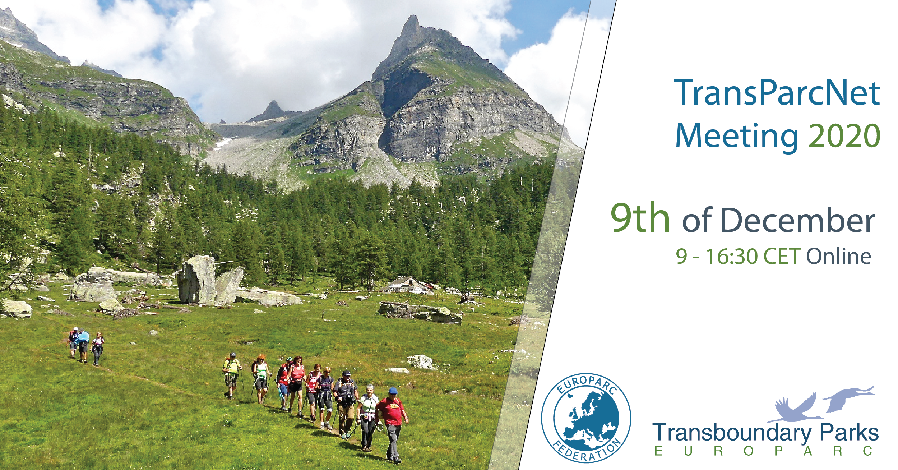

TransParcNet Meeting 2020

Transboundary Protected Areas: cooperation in COVID time
Wednesday, 09th of December 2020, 09:00-16:30 CET
Online

The EUROPARC Transboundary Parks Programme “Following Natures Design” is a special verification and certification system that aims to promote and facilitate transboundary cooperation between European Protected Areas.

The TransParcNet is the network of all certified EUROPARC Transboundary Parks.

The Annual TransParcNet meeting is usually hosted by one of the members of the network. This time, due of COVID19 emergency and travel restrictions, it is organized by EUROPARC online, and is restricted to TransParcNet members and other invited cross-border European protected areas.

A special thanks to the European Commission and IUCN representatives for their presence and thanks to all participants. We very much look forward to a fruitful and enlightening exchange and discussion.

More info about the program, the network and the previous TransParcNet meetings: https://www.europarc.org/nature/transboundary-cooperation/

Contact: stefania.petrosillo@europarc.org

Co-funded by the European Union.
The organisation of this event has been supported financially in the framework of the European Commission’s (Directorates General Environment and Climate Action) LIFE + funding programme of operating grants for European Environmental NGOs. Responsibility for the information and views expressed in the event lies entirely with the authors.

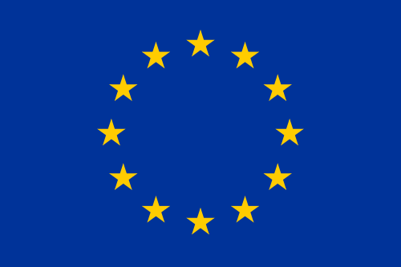

PROVISIONAL AGENDA
Facilitator: Stefania Petrosillo – EUROPARC Federation
09:00 | WELCOME  Ignace Shops – EUROPARC Federation
09:10  09:30 | Presentation and update of EUROPARC Transboundary Program  Riina Tervo, EUROPARC TB Task Force  Q&A, debate
09:40  10:10 | EU cohesion policy and INTERREG support for cross-border cooperation  Maud Skäringer, European Commission- DG REGIO  The role of cross-border cooperation in the EU Biodiversity Strategy 2030  Przemyslaw Oginski, European Commission- DG ENV  Q&A, debate
10:25 | BREAK
10:35  10:50 | IUCN transboundary conservation  Boris Erg, IUCN WCPA Transboundary Conservation Specialist Group  Q&A, debate
11:05  11:20 | Presentation of a new Transboundary candidate  Hauke Zirfas, Int. Naturpark Bourtanger Moor - Bargerveen e.V. (D-N)  Q&A, debate
12:35 | Presentation of workshops  Daniele Piazza, Binntal Veglia Devero Nature Parks (IT-CH)  Stefano Santi, Leo Reyrink, EUROPARC TB TaskForce
12:45 | BREAK
From 13:00  to  14:00 |  | LUNCH TIME & NETWORKING  Virtual tables available for participants who like to have lunch or take a coffee together.  (PLEASE, BRING AND VIRTUALLY SHARE TYPICAL FOOD AND DRINK FROM YOUR AREA!!)

From  14:00  to  16:00 | WORKING GROUP 1:  COVID time and transboundary cooperation  Facilitators: Daniele Piazza | WORKING GROUP 2:  New projects for the network  Facilitators: Stefano Santi, Leo Reyrink

16:00 | Short presentation of working groups results  Daniele Piazza, Binntal Veglia Devero Nature Parks (IT-CH)  Stefano Santi, Leo Reyrink, EUROPARC TB Task Force
16:10 | Final debate and comments
16:25 | Conclusions  Carol Ritchie, EUROPARC Federation
16:30 | END OF THE MEETING

