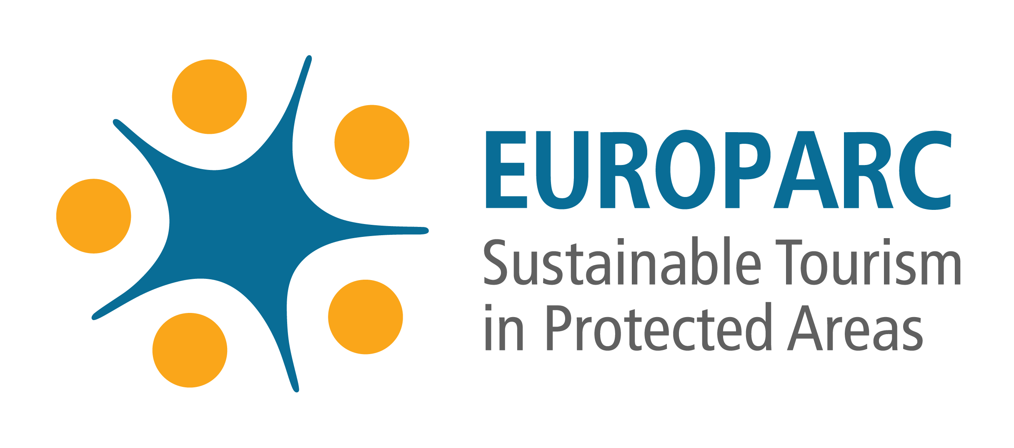

Registration Form

European Charter for Sustainable Tourism: Candidate Parks

This form should be completed by the Protected Area authority as early as possible during the process of implementing the Charter, in order to register as a “Candidate Charter Park”.
Upon registration, the protected area will be entered onto the European Charter database of participating parks, and will be sent the current application documents for Charter membership. Applications for Charter membership will only be accepted from Protected Areas which have previously registered as candidate Charter parks, and subject to an agreed timetable.

Registration carries a fee. Please see information 'Costs and Conditions' for further details.

Protected areas which join the Charter are required to be members of the EUROPARC Federation. Protected areas which are not already EUROPARC members will be requested to join the Federation upon submission of this registration form.

Clarification on this requirement:
A protected area needs to be a full member of the Federation to apply for the Charter as long as the protected area is its own legal entity and has its own budget. A protected area that does not have its own legal entity can however also apply to the Charter if it is represented by its higher authority at the Federation (i.e. the higher authority needs to be a full member to the Federation for a protected area to receive the Charter).

Please return this form to: EUROPARC Federation, Waffnergasse 6, 93047 Regensburg
Fax: +49 (0)941 59935980, e-mail: sustainable.tourism@europarc.org

All data exchanged between the EUROPARC Federation and candidate parks is confidential.

Name of Protected Area
Country
Address

VAT number (if any)
Invoicing reference (if any)
Telephone
Fax
Email
Web address
Name of Director

Name of main contact person
Official position
Telephone
Email

Year of establishment of Protected Area
Size of Protected Area (ha)
IUCN Management Category
National Management Category (if different)
EUROPARC member since
EUROPARC Federation membership number
Is your protected area a legal entity?
(legal entity = an individual or organisation which is legally permitted to enter into a contract)
If yes, which type?
If no, who is the higher authority or legal entity you belong to deciding upon your contracts?
Do you have authority to decide upon your protected areas budget?
If no, who is the authority deciding upon your expenses?
With reference to the Charter requirements, please explain briefly whether your Protected Area
has started to work on the following and if so, the stage of development:

- Engaging in a process of wide consultation with all those implicated by tourism in and around the protected area, in its development and management. Establishment of a permanent forum or equivalent arrangement between all those directly concerned.

- Defining a medium term Strategy (5 years) for sustainable tourism development in the area; presenting this in the form of an Action Plan

Please indicate the time scale being followed in your Protected Area for the consultation
process and development of the tourism Strategy & Action Plan.

When do you anticipate completing your Strategy and Action Plan, and being able to make a
full application for membership of the Charter (year and quarter)?

Signed by the President or Director of the Protected Area (as appropriate):

(Please sign and print your name)

......................................................................
Date:

For EUROPARC use only: Registration received on: ..........................................................

Entered onto database: .............................................................

Charter parks must be members of the EUROPARC Federation. See note in introduction above.
Please contact the EUROPARC office if unknown.

